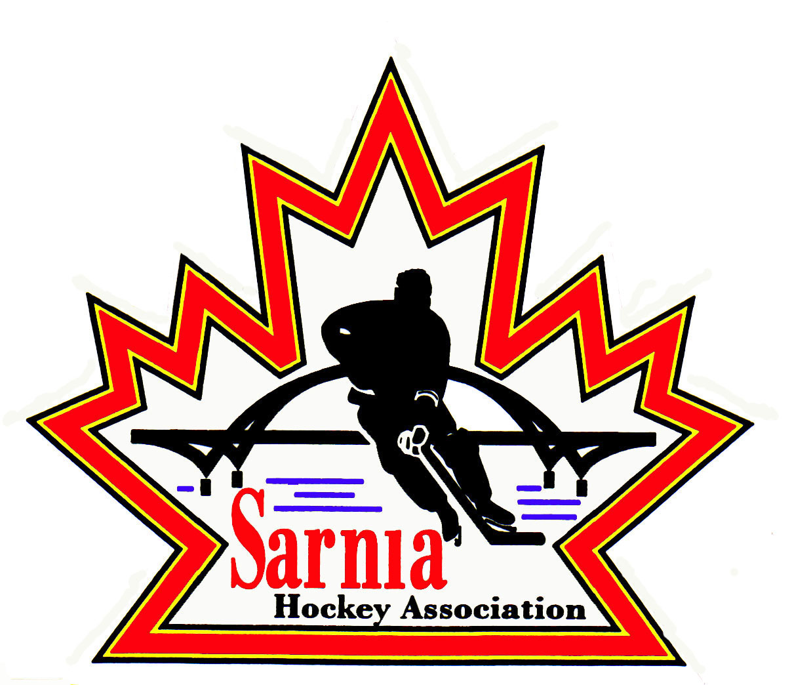

Sarnia Hockey Association

Minutes | Date: MARCH 19, 2025 | time 7:00 pm

Meeting called by | Paul Walsh, President
Type of meeting | Regular
Secretary | Kelly Lane, Recording Secretary

Welcome | Paul Walsh, President, and meeting Chair welcomed everyone and called the meeting to order at 7:08 pm.

ATTENDANCE | Tom Babcock, Andrew Beasley, Jerry Bernardo, Alister Brown, Jeff Fogal, Pat Forbes, Kelly Lane, Linda Lauzon, Don McGugan, John Mellor, Kyle Mellor, Blake Morrison, David Penner, John Ritchie, Wayne Scarrow, Lesley Smith-Taylor, Kevin Taylor, Tim Turner, Paul Walsh, Barb Walsh  Regrets: Heather Amaral, Jacquie Beasley, Emily Brown, Darren Chevalier, Ian Dunn, Chuck Ewart, Terry Gray, Dan Hunt, Bonny Marcy, Ted Pendle

ACCEPTANCE OF MINUTES | MOTION #250319-001  “That the Minutes from March 4, 2025, be accepted as presented.” ( J. Mellor/K. Taylor )  Carried

TREASURER’S REPORT | - Treasurer’s Report will be presented at the next meeting.

BILLS TO BE PAID
  Recipient | Expense | Amount
  Bills for this month will be presented at the next meeting. |  | $

REP DIRECTOR | PLAYER MOVEMENT:  - A meeting occurred specifically around registration, team formation, and prep skates.  - There was a meeting with Registrars to go over new protocols, although there are changes almost every day.  U9 MD and BELOW PLAYER MOVEMENT:  - Players will be required to participate in Alliance in accordance to residential boundaries. MD Tryouts may be allowed in Spring and Fall.  - Must comply with OHF regulations. Our Association will be in the fall for this age group.  - No update on U9 half ice. It may come down to what parents want versus what may be better for the players.  PREP SKATES AND TRYOUTS:  - Prep skates are mandatory for U15 and below. Minimum of 4 and Hockey Canada Pathways has some prep skate drills based on 50 minute ice times.  - Prep Skate registration is set up and is ready for when we want to launch registration.  - NRP players cannot sign up this year for prep skates because it is still 2024-25 season.  - There are specific tryout dates which we must adhere to and we will.  - AAA has not posted their prep skates on their website yet.  - Players are not insured if they do prep skates with another Association.  - U10-13 must start their tryouts on weekend of OHF Championships.  - We looked at what we charged last year for prep skates and tryouts and this year we will do 4- 1 hour skates. Cost will be $120 for 4 prep skates. For tryouts the cost will be $70 per tryout.  - We will do separate tryout registrations for AA and BB. If you make AA and had signed up for BB tryout you will be reimbursed for those tryouts.  REP COACH INTERVIEWS:  - Interviews are being conducted next week.  - We have 36 applicants for 19 teams.  - Interviews are scheduled with time at the end to discuss ranking. Rep review committee will review rankings and coach ratification will be at the next SHA board meeting.

POLICY CHANGE | MOTION #250319-002  “That we proceed with Policy 2.07 Investigation Procedure for board approval.” (K. Taylor/Scarrow)  Carried  - PRAC has occurred and ready to be reviewed by the Board.

ICE DIRECTOR | - Couple of teams still playing  - Prep skates to be posted tonight.  - Working on bills and setting up tryouts.  - Will get ice out to teams for the next couple of weeks.  - Alliance Championships – 18 days of ice to distribute to those teams as well as those still in playdowns.  - It needs to be noted that sometimes there is short notice for contracts for playdowns so teams need to understand this.

REC EQUIPMENT DIRECTOR | VOLUNTEER APPRECIATION NIGHT:  - Volunteer Appreciation night is April 14. Invites have gone out via email where you can RSVP. Good attendance confirmed so far. It is also a send off for U18 rep players. Directors need to ensure those players get invited.  - It was sent out as a calendar invite.  COACH AND MANAGER OF THE YEAR AWARDS:  - Coach and Manager of the Year award presentations will occur at the Volunteer Appreciation Night as well.  - It would be appreciated that Directors try to ensure that the recipients are attending if possible to receive their award.  REC VENDOR SELECTION:  - Last year we did a one-year bid with an option to extend.  - Tim Hortons dropped sponsorship for U9 so we have to now supply those jerseys.  - Planet Stitch was the low bidder and Rec Equipment Director recommends that we continue with them as supplier for Rec jersey/socks other than for U9.  - U9 jerseys and socks will be supplied by Team Outfitters.  - There is a benefit to having 2 suppliers. We have another option in case of supply issues.  - Conversation needs to occur with Planet Stitch to ensure that the same level of service is provided for Rep, Rec and Select Divisions.  - Key is that we want all the teams to look the same.  - It is a bid process so no motion is required.

AAA REPORT | - A Lambton AAA meeting occurred last night.  - Lambton AAA is trying to figure out the no borders change and discussing how best to do tryouts.  - They are supposed to be posting their dates for tryouts this week.  - They also discussed body checking and boundaries for U9 players playing up.  - Prep skates were also discussed.

CORRESPONDENCE | - Received correspondence from a gentleman moving into our community and wanting to start a special needs hockey program in the community.  - He sent links to other Associations that offer them. Some centres have them and these leagues are sanctioned such as Kitchener. Many centres in Ontario offer this program.  - Concern is that we don’t have the ice capacity in our community to offer an additional program.  - It was noted that some special needs players go to the sledge hockey program.  - This is not limited to youth but adults also.  - London has a good program and some young people from our area go there to play.  - The First Shift Program would also be an appropriate program.  - President will respond with this information.

PHOTOGRAPHY | - Doing parking lot pick up again this year as photos will not be ready by season end.  - Ensure that the Directors communicate that information regarding photo pick up dates and times will be put on the SHA website.

SELECT DIRECTOR | MOTION #250319-003  “That we allow U13 and U15 Select Teams to attend an additional tournament.” (McGugan/Forbes)  Carried  - If allowed they will look at tournament options.  - Both teams are below the limit for games. Currently they are at 20 games.  - The extra tournament would be in addition to 3 tournaments that they are allowed.  - The teams must adhere to the 30-game limit including the Championships.  - Ensure that parents are onboard with this additional tournament.

NEW BUSINESS | 2025/26 BOARD POSITIONS UP FOR ELECTION:  - SHA President identified what positions are up for election this year:  BOARD POSITIONS FOR ONE-YEAR APPOINTMENT:  - Board Members whose positions are up for election are asked to contact Nomination Committee members Wayne Scarrow and Paul Walsh with their intentions to run again or to identify interest in another position.  - The positions will be put up on the website soon.  ALLIANCE AGM:  - Alliance AGM is scheduled for June 20-21 at Four Points Sheraton in London.  - Golf at Fire Rock on June 20 with dinner following at the hotel.  - June 21 is the AGM meeting from 8:30am to noon.  - If interested in attending, please contact Paul Walsh.  - We are allowed 10 delegates on a first come first serve basis.  - Registration deadline is May 31.  NEXT MEETING:  - Next meeting is Tuesday, April 1, 2025 at Clearwater Arena Lower Hall.
  POSITION (2 YEAR POSITIONS) | CURRENT MEMBER
  First Vice-President | Kevin Taylor
  Vice-President Recreational League | Jerry Bernardo
  Director of Recreational League U15 | Dan Hunt
  Director of Recreational League-U11 | David Penner
  Director of Recreational League U6/U7 | Brendan Douglass
  Director of Recreational League Foundations | Jason Teather
  Director of A/AA Representative Teams | Terry Gray
  Development/Skills Director | Vacant
  Ice Director/Scheduler | Linda Lauzon
  Recreational League – Tournament Director | Jeff Fogal
  Sponsorship Director – Recreational Teams | Jerry Bernardo
  Recreational League Referee Director | Ian Dunn
  Director of Mental Health | Tom Babcock
  Website Director | Andrew Beasley
  Equipment Director Representative Teams | Tom Babcock
  POSITION | CURRENT MEMBER
  Director at Large-AAA Representative | Tim Turner
  Director at Large-AAA Representative | Cris LaPointe
  Director at Large-Select Teams | Don McGugan
  Director at Large-Silver Stick Tournament | Paul Douglass
  Director at Large | John Ritchie
  Director of Fundraising | Bonny Marcy
  Alliance Rep Council | Paul Walsh
  Alliance Rec Council | Jerry Bernardo
  Director of Recreational League U18-21 | Vacant

adjournment | MOTION #250319-004  “That the meeting be adjourned.” (K. Mellor/Babcock)  Carried

Paul Walsh Kelly Lane
President Secretary

